Prog Readme File poe part1

In this word document, this will be a manual on how to compile and run the Replace book game for part 2 of the POE. So let get started.

How to setup the project:

First you would have to download the project file, whether it be from vc learn or GitHub.

This time I am going to show how to get the project from GitHub. Open the GitHub link in a web browser(the link will be provided in the folder on vc learn) and you should see the application.

Click on the green button that says code and it will give you the GitHub repositories link, make sure it is on the HTTPS tab and copy the URL.

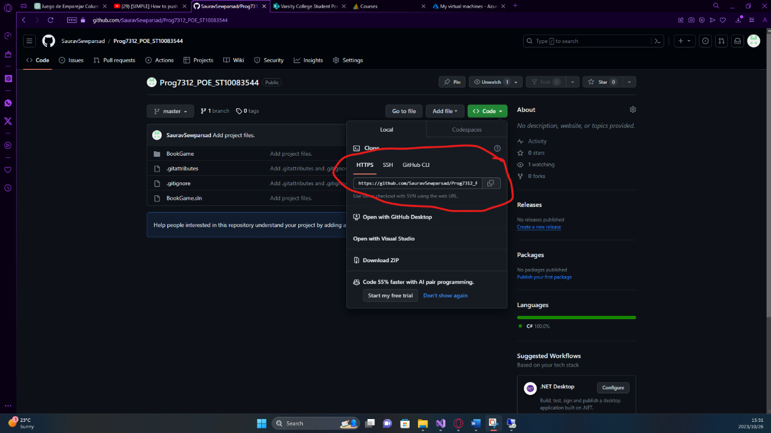

After copying the link open your visual studio

And click on the “clone a repository” tab. This opens a new page where you will past the link you copied from GitHub. Paste the URL you copied into the tab and click the clone button.

After letting all the code and images load you will be greeted with this screen down below.

And that is how you are going to load the application from Github.

How to run the application

Now that you are all setup, you are now ready to run the application, Jut click on the green play button at the top of the screen in the centre of the application.

How to use the Application:

After clicking on the green play button you will be face to face with a pop up window like this.

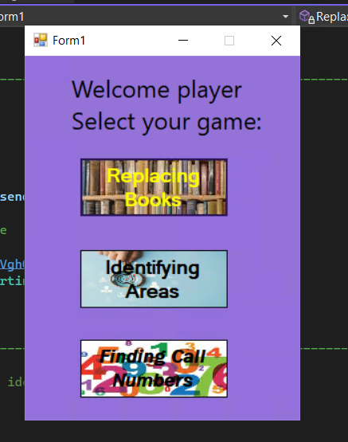

This is the home page window where the user can select what game they wanted to play. The Replacing book and Identifying Areas tab were played last time now we are going to play the Finding Call Numbers quiz game.

Now click on the Finding Call Numbers button

A new window will pop up and you can then begin playing the game

On the screen you will be greeted with background music and 4 buttons, the “Exit” button will take you back to the home page to select another game, the “About” button will tell the user how to play the game, the “Close" button will close the application, but the user will lose all progress. The “Ready” button will begin the game when the user clicks it. When the user clicks either the Exit or Close buttons they will ask the user if they want to exit the application/game.

When the user click the “Ready” button the game will start and the timer will be displayed. The ready button will also disappear and the question along with 4 buttons will appear.

The Question is randomly selected from my text file and the user will have to choose the correct option from the buttons. The answer will be the closest integer to the question. The quiz will consist of 3 levels and the levels get harder. The question will also change and the options on the buttons will be randomized.

If the user gets the answer correct, then they will be awarded 100 points. If the user is getting the question wrong a buzzer will be played to tell the user they got the question wrong, and not be awarded any points.

Once the game is over the user will be given the score and percentage of how many answers they got correct. When the user clicks the ok button the game will reset.

If the user runs out of time the game will end the user will lose all their points and be sent back to the Ready screen.

The point system is the gamification feature I am using in this game.

The user can play the game over and over if they want and can exit any time they want.